**Home ,**

**HOME**

**MISSION**

To serve our clients by providing the highest quality professional services that enable them to achieve increased and more sustainable impact for the communities and institutions they serve.

**VISION**

To be the leading research, evaluation, and training hub in Ethiopia and Africa known for delivering excellence.

**VALUES**

• **Integrity**: We uphold the highest standards of personal and professional ethics, honesty, and trust.

• **Respect**: We value everyone with respect, civility, and fairness.

• **Collaboration**: We work as a team and collaborate with others for synergy, innovation and continual improvement.

• **Excellence**: We are able to provide leadership, best practices, research, support, and/or training in different thematic areas.

[**SEGEL RESEARCH &TRAINING CONSULTING PLC.**](https://segelconsult.com/?q=node/4)

SEGEL Research and Training Consulting PLC (SEGEL) is a consultancy firm providing services to bilateral organizations, government ministries and NGOs. SEGEL houses experts, both academicians and practitioners, from diverse backgrounds and with a broad range of expertise. Our multi-disciplinary team consists of experts in the fields of education, food security, health, social development, humanitarian vs. social accountability, gender, and capacity building.

**FOOTER**

Social medias , Footer for other page redirect

**WHAT WE DO**

we provide high quality, tailor-made consultancy services to governmental and non-governmental organizations and donor agencies in both the humanitarian and development sectors. For each particular project or engagement, we assign a team of experts in the given sector, language, and geographic area, drawing on our national and global network. At the same time, we invest in innovative approaches such as new research methodologies, as we strive continually to grow in terms of what we can offer our clients.

We attract and work with the most knowledgeable and passionate professionals and reputable research institutions, and we provide a collaborative culture for synergy and impact. We deliver high quality consulting services, and are known for meeting deadlines and working effectively.

**SEGEL offers a variety of services:**

1. **Evaluation**: We conduct baseline, midterm and final evaluations using qualitative and quantitative data collection methods. We have experience with humanitarian and DDR project evaluation, value chain research, market research, urban studies, exploratory studies, case studies, and ethnographic studies. Some of the methods we employ are: digital data collection using smartphones, focus group discussions, participant observations, in-depth interviews, surveys, desk reviews, and literature studies. For data analysis, we use up to date versions of software, including R, SAS, SPSS and Nvivo.

2. **Development of educational materials:**We have rich experience in developing manuals as well as educational books.

3. **Capacity building**: Our staff is proficient in preparing training curricula and providing corporate training on accountability, the Sphere Project, project cycle management, and results-based monitoring. Our CEO is a globally accredited Sphere Project Trainer of Trainers in Quality and Accountability Standards. We have provided more than 15 training programs on these and similar topics over the last two years for participants from more than 110 organizations in Ethiopia.

4. **Technical guidance**: We offer guidance in proposal writing, as well as editing and translation services for research papers for publication in international journals, magazines, and books.

**FOOTER**

**DOCUMENTATION**

Pictures

**Projects**

|  |  |  |
| --- | --- | --- |
| PROJECTS | CLIENT | WHEN |
| Baseline Survey on Safety, Security, Access to Justice and Victims Support Services for Host and Refugees Communities in Gambella, Ethiopia | [UNHCR(link is external)](https://www.unhcr.org/) | December - February 2019 |
| Mapping of Pastoral Communities in 27 Selected Woredas of Somali Regional State | [AMREF Health Africa(link is external)](https://www.amrefusa.org/) | February - July 2018 |
| Basic Service Mapping for Urban Refugees in Addis Ababa | [Norwegian Refugee Council(link is external)](https://www.nrc.no/) | October – December 2018 |
| Mapping of Pastoral Communities in 15 Selected Woredas of Afar Regional State | [AMREF Health Africa(link is external)](https://www.amrefusa.org/) | September - December 2018 |
| Endline Evaluation of project entitled "Women for Women: Creating Opportunities for Women in Enterprise Development in Addis Ababa | [CARE Ethiopia(link is external)](https://www.care.org/country/ethiopia) | July - September 2018 |
| The Role of Climate Change on Agricultural Performance and Impact Assessment of Adaptation Methods: the Case of Kafa Biosphere Reserve | [NABU (Nature and Biodiversity Conservation Union)(link is external)](https://en.nabu.de/) | May – November 2018 |
| Context Analysis of Pastoral and Agro-pastoral Areas to Enrich and Update Draft Policy and Strategy Framework | [Mercy Corps(link is external)](https://www.mercycorps.org.uk/) | November 2017 -September 2018 |
| R4 Rural Resilience Program Evaluation in Amhara Regional State of Ethiopia | [Oxfam America(link is external)](https://www.oxfamamerica.org/) | November 2017 – March 2018 |
| Final Evaluation of Hope for Eritrean Refugees in Ethiopia Project | [ZOA(link is external)](http://www.zoa-international.com/ethiopia) | April – August 2017 |
| Impact Assessment and Cost Benefit Analysis of Agricultural Taxation in Ethiopia | [AGRA(link is external)](https://agra.org/)[ATA(link is external)](http://www.ata.gov.et/) | January - July 2017 |
| Effectiveness of Upgrading Teachers’ Education Program of Primary Schools in Tigray Regional State | [British Council(link is external)](https://www.britishcouncil.org/) | March - May 2017 |
| End line evaluation for increasing Smallholder Agricultural productivity through improved Farmer Training Centers (ISAP) project | [Oxfam America(link is external)](https://www.oxfamamerica.org/) | November – December 2016 |
| Final Evaluation of Youth Education Pack (YEP) and Education (Accelerated Learning Programme) in Shire, Assosa, Gambella, and Dollo Camps, Ethiopia | [Norwegian Refugee Council(link is external)](https://www.nrc.no/) | Sept 2016 - Nov 2016 |
| Final Evaluation of the Seed Recovery Project in Oromiya, SNNPR, Tigray, and Amhara Regions, Ethiopia | [Catholic Relief Services(link is external)](https://www.crs.org/) | Aug 2016 - Sept 2016 |
| Final Evaluation of the Hosanna Nutrition Based Livelihood Support Project in Hadiya and Kembata Tembaro Zone, SNNPR, Ethiopia | [Trócaire/CAFOD/SCIAF(link is external)](https://www.trocaire.org/whatwedo/wherewework/ethiopia/) | Aug 2016 - Sept 2016 |
| Her Choice: Building Child Marriage Free Communities. Baseline Study in Oromia Region, Ethiopia | [AISSR(link is external)](http://www.aissr.uva.nl/)[Kinderpostzegels(link is external)](http://www.kinderpostzegels.nl/) | June-Aug 2016 |
| Development of a Strategic Policy for National Science, Technology and Mathematics Education | [JICA(link is external)](http://www.jica.go.jp/english/)[MOE(link is external)](http://www.moe.gov.et/) | Until March 2016 |
| Development of a School Code of Conduct Implementation Manual and Monitoring Tools | [Save the Children International(link is external)](http://www.savethechildren.net/) | Dec 2015 - Mar 2016 |
| Baseline survey of Hope for Eritrean Refugees in Ethiopia Project | [ZOA(link is external)](http://www.zoa-international.com/ethiopia) | Sept – Dec 2015 |
| End-line Survey of Integrated Livelihood through Mung Bean Production Project in East Harerghe Zone of Oromiya Regional State | [ZOA(link is external)](http://www.zoa-international.com/ethiopia) | Nov 2015 – Jan 2016 |
| Assessment of Enabling Environment for Investment in Children Initiatives in Ethiopia | [Save the Children International(link is external)](http://www.savethechildren.net/) | Sept – Dec 2015 |
| Map Reading Text Book for Grade 11 and 12 Geography Teachers | [Ministry of Education (Ethiopia)(link is external)](http://www.moe.gov.et/) | Sept – Nov 2015 |
| Final Evaluation of Education and Child Protection in Emergencies in Tiergol Town, Akobo, Gambella Region, Ethiopia Project | [ZOA(link is external)](http://www.zoa-international.com/ethiopia) [UNICEF(link is external)](http://www.unicef.org/) | July – Sep 2015 |
| In-house Consultant for Social Infrastructure sector of Japan International Cooperation Agency (JICA) | [JICA(link is external)](http://www.jica.go.jp/english/) | June – Nov 2015 |
| Conducted Training on Internal Accountability | [IntraHealth(link is external)](http://www.intrahealth.org/) | Oct 2014 |
| Resource Mobilization Strategy/ Fundraising Strategy for Ethiopian Cities Project | [Ethiopian Cities Association(link is external)](http://www.ethiopiancities.org/) | Dec 2013 – Feb 2014 |
| In-Depth Analysis of Investment in Children in Ethiopia | [Save the Children International(link is external)](http://www.savethechildren.net/) | Oct 2013 – Jan 2014 |
| Evaluation of the Contribution of CSOs towards Health Sector in Ethiopia | [CCRDA(link is external)](http://www.ccrdaeth.org/) | Aug – Dec 2013 |
| Conducted Sphere Project Trainings | [CCRDA(link is external)](http://www.ccrdaeth.org/) [CAFOD(link is external)](http://www.cafod.org.uk/) [TROCAIRE(link is external)](http://www.trocaire.org/) [Sciaf(link is external)](http://www.sciaf.org.uk/) | Feb 2013 - Feb 2014 |
| Provided Training on Accountability, Project Cycle Management, Monitoring and Evaluation, and Humanitarian Accountability Partnership (HAP) for representatives of more than 150 NGOs in Ethiopia | [CCRDA(link is external)](http://www.ccrdaeth.org/) | Jan 2013 - Mar 2014 |
| Organizational and Technical Capacity Assessments of Care for the Poor | [CCRDA(link is external)](http://www.ccrdaeth.org/) | Oct - Dec 2013 |
| Reviewed, Evaluated and Translated from English to Amharic 1) Wereda Contingency Planning Guidelines and 2) Wereda Disaster Risk Mitigation/Adaptation Planning Guidelines | [Ministry of Agriculture, DRMFSS(link is external)](http://www.moa.gov.et/home) | Oct 2013 – Feb 2014 |
| Prepared a Regional Report on the Implementation Status of the International Conference on Population and Development/Programs of Action (ICPD/PoA) for the IGAD Region after undertaking exploratory missions to the IGAD Member States: Djibouti, Ethiopia, Kenya, Somali (Hargeisa and Mogadishu), South Sudan, Sudan and Uganda) | [JICA(link is external)](http://www.jica.go.jp/english/) | Oct - Dec 2013 |
| Regional Assessment of Reproductive Health (RH) situations in the IGAD member states (see above countries) and developed database on RH for the region | [IGAD(link is external)](http://www.igad.int/) | Sept - Dec 2013 |
| Participatory Citizens Satisfaction End line Survey Program in Assosa, Benishangul Gumuz Regional State | [GIZ(link is external)](http://www.giz.de/en/html/index.html) | Jan – Feb 2013 |
| Developed/Updated the IGAD Gender Policy and Strategy (2012-2020) | [IGAD(link is external)](http://www.igad.int/) | 2012 |
| Baseline Survey: Good Governance and Decentralization Program in Assosa, Benishangul Gumuz Regional State | [GIZ(link is external)](http://www.giz.de/en/html/index.html) | Dec 2012 |
| Training Manual: Income Generating Activities | Network for Integrated Development Ethiopia | Dec 2012 |
| Partnership Guidelines for Concern Worldwide Ethiopia | [Concern Worldwide Ethiopia(link is external)](http://www.concern.net/) | Nov 2012 |
| End of Project Evaluation of Miyo Woreda Emergency Response Project, Borena Zone | [Christian Aid(link is external)](http://www.christianaid.org.uk/) | Nov 2012 |
| Participation Guidelines, Quality and Accountability Implementation Plan and Complaints Handling Mechanism for Christian Aid in Ethiopia | [Christian Aid Ethiopia(link is external)](http://www.christianaid.org.uk/) | Oct 2012 |
| Training Manual: Overview of Humanitarian Accountability and Quality & Accountability Initiatives | [CCRDA(link is external)](http://www.ccrdaeth.org/) | Oct 2012 |
| Training on Community Conversation Enhancement for Partners and Staff of Catholic Relief Service in Adama | [CCRDA(link is external)](http://www.ccrdaeth.org/) | Oct 2012 |

**News**

**Pic..**

**Development of a School Code of Conduct Implementation Manual**

Picture

Save the Children asked SEGEL to develop a “School Code of Conduct Implementation Manual and Monitoring Tools”, a practical, child protection resource book to be used at school level so that the school community has a clear common understanding of practical implementation of child protection mechanisms/practices.

The aim of the manual is to serve learners, teachers and other education personnel in understanding their responsibilities and accountabilities to ensure children’s wellbeing within the school environment, as well as their role in the implementation of the school code of conduct.

The work is part of Save the Children’s child protection program for which they received a grant from the European Commission entitled “Create Enabling and Supportive Environment for Children in six woredas of East Gojjam and North Wollo Zones of Amhara Region”. The development of the manual builds upon the existing School Code of Conduct developed in 2014 by the Amhara Region Bureau of Education and Save the Children.

**OUR METHODOLOGY**  
In January and February 2016 we made a 10-day visit to East Gojam and North Wollo zones to seek input from boys and girls from Grade 1-8 from four primary schools, teachers, PTAs, school principals, and from the Education and Women, Children and Youth Affairs offices and bureaus at woreda and Amhara regional level.

Learners from Grade 1-8 shared with us many concerns and challenges regarding child protection existing in the area:

o Physical violence: hitting, beating  
o Emotional abuse: insulting, humiliating, threatening, discrimination  
o Sexual abuse and exploitation: harassment, violence  
o Neglect and exploitation: lack of supervision, expulsion,  
o Early child marriage  
o Child trafficking: Sending Children to Arab countries  
o Abduction  
o Rape  
o FGM  
o Exposure to dangerous phenomena: traffic accident, schools without fences

We took these findings back to Addis Ababa where the writing of the Amharic manual took place. We developed three separate manuals for teachers, learners from Grade 1-4 and learners from Grade 5-8. To ensure that each manual is user-friendly and attractive the research team worked together with illustrators and Amharic language editors.

The final School Code of Conduct Implementation Manual consists of three separate manuals as well as user-friendly monitoring tools that will facilitate the initiation, implementation, monitoring and evaluation of the impact of the school code of conduct.

**About segel (dropdown menu)**

**Who we are**

SEGEL was created in November 2012 by Mr. Amha Ermias Tefferi, a lecturer from Addis Ababa University and at that time Humanitarian Program Specialist at Christian Aid Ethiopia. Observing a need for consultancy services of better quality and efficiency in the country, Amha decided to set up his own consultancy firm and strategically build it up around two overarching principles: learning and continual improvement, and open policy. This means that at SEGEL we focus on learning from experience in order to continually improve our performance.

Since 2012, SEGEL has evolved into a dynamic and growing private limited company working in Ethiopia and the Horn of Africa. Our senior technical staff members have many years of experience in academia as well as in the field as practitioners and hold advanced degrees. In addition, we work with a pool of trusted national and international experts. Our staff and collaborating professionals include experts in development, education, health, social sciences, and other relevant disciplines. Our guiding principles are:

• **Synergy**: for Quality Management: We bring both local and international experience from our global network, allowing us to manage projects for clients at both a national and international level, and providing access to the best of SEGEL’s expertise in consulting, research, evaluation, and training. By working impeccably together as one team, we serve our clients wherever they need us.

• **Innovation**: Through our international network, we are on top of the latest developments in research, consulting, and training. We use this information by innovatively adapting it to the local context and so maximizing the quality of the work that we do.

• **Quality**: We have developed in-house guidelines and protocols to provide training to data collectors and assistant researchers, whom we observe and monitor before they conduct any research and evaluation for us.

**Our team**

↓ Slide [**Home**](https://www.segelconsult.com/)**» Our Team**

# Our Team

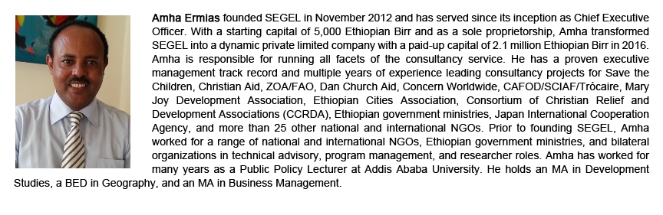

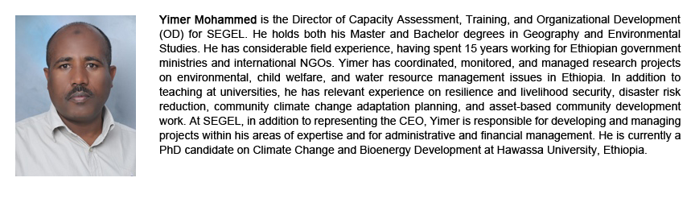

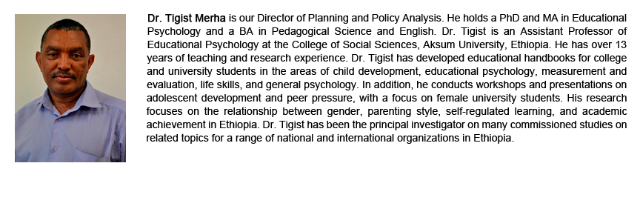

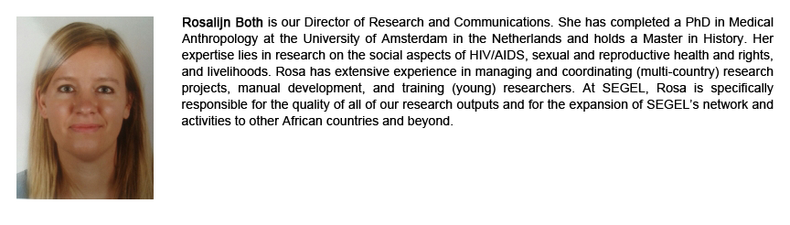

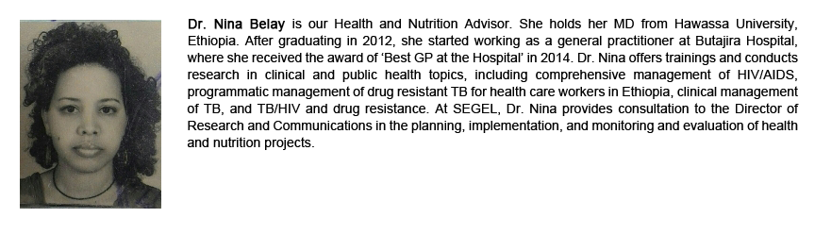

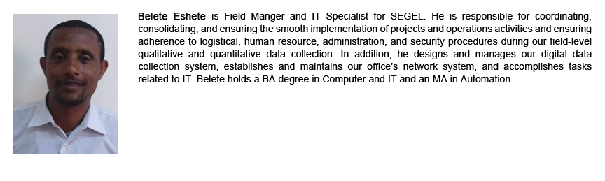

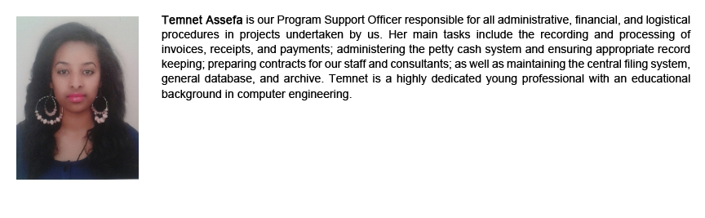

## Follow Us

**Organizational Structure**

SEGEL has grown steadily since its incorporation in Ethiopia in 2012; the company’s 2015/16 capital totaled nearly 2.1 million Ethiopian Birr and we currently employ more than 20 permanent and temporary staff. An expatriate and full‐time Director of Research and Communications leads health and livelihood related studies and evaluations. Our Director of Administration and Finance oversees SEGEL’s financial management with partial support from another staff member. SEGEL’s head office is located in Addis Ababa. Our organogram is presented below.

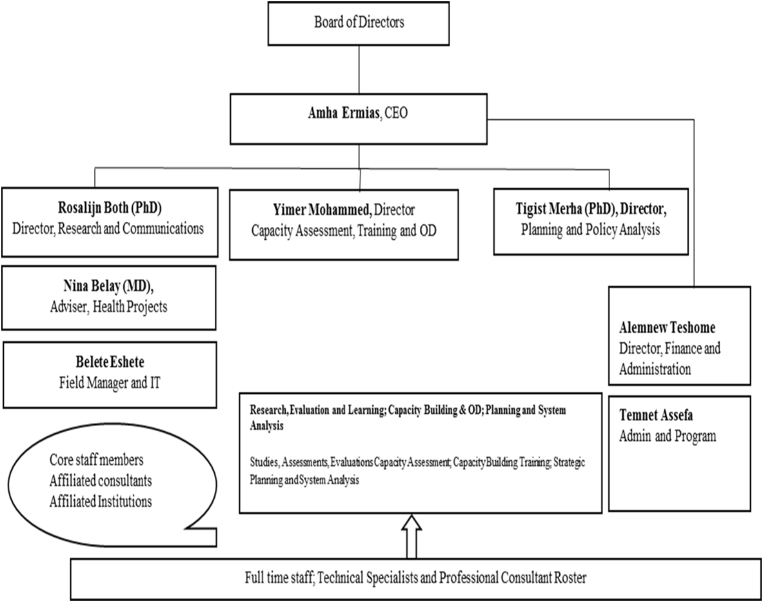

**Organizational capability**

SEGEL relies on strong in-house experience and a network of expert consultants to consistently manage assignments effectively and deliver high quality products. We conduct much of our work at senior and systemic levels, considering Ethiopian law and the local context. Our consultants have experience in working for multilateral and bilateral organizations as well as NGOs in Ethiopia and beyond.

Most importantly, we have established systems and procedures to optimize team performance and the quality of deliverables. We have proven capacity in managing multi-disciplinary teams working on multi-site studies and with diversified groups.